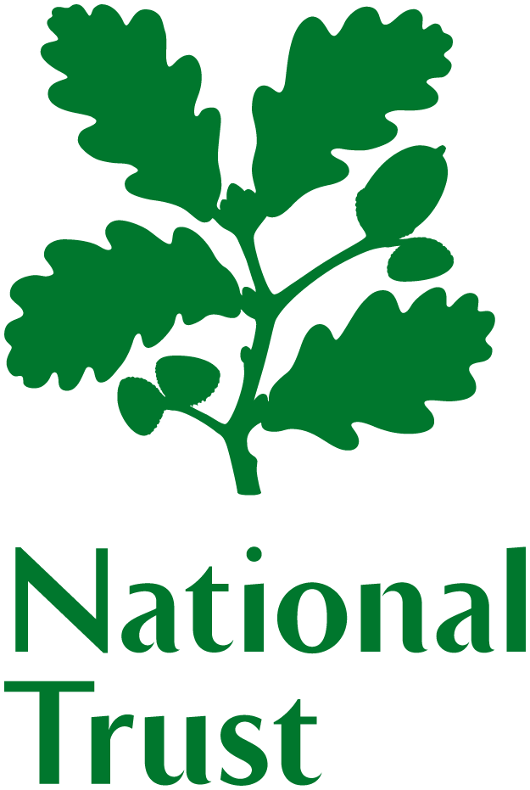 | National Trust  Regional Advisory Group Members
 | Northern Ireland

Help Shape the Future of Northern Ireland’s Natural & Cultural Treasures!
Do you light up at the sight of a wild coastline, a sweeping landscape, or a place steeped in history?
Do you believe our special places deserve care, passion and bold ideas?
Do you want more people to enjoy, celebrate and protect the beauty on their doorstep?
If that sounds like you, then the National Trust wants to hear from you! We’re looking for enthusiastic volunteer members to join our Regional Advisory Group in Northern Ireland and help shape our work for generations to come.

What is the Regional Advisory Group?
It’s a vibrant mix of volunteers from many walks of life, all united by one purpose:
to champion conservation and ensure public benefit for all.
As part of the Group, you will:
- Offer strategic insight across conservation and business activities
- Support and advise the National Trust’s Northern Ireland senior management team
- Meet four times per year, and be an advocate for our work
- Collaborate on projects that make a real‑world difference
- Offer your expertise and guidance to our team on an ad hoc basis

Who We’re Looking For
We welcome people from all backgrounds, especially those with experience or passion in:
- Community engagement and/ or reaching urban audiences
- Tourism, including travel trade and an all‑island perspective
- A strategic approach to culture & heritage — including museums and collections
- Climate adaptation and mitigation
- Philanthropy and fundraising
If you care deeply about people, places, and the future, you’ll fit right in.

How to Apply
To request an application form or find out more, contact:
Rachael McCrisken – Rachael.McCrisken@nationaltrust.org.uk
Closing date: 24th April 2026
Interview date: 11th May 2026

Be Part of Something Bigger
Join us in protecting Northern Ireland’s stories, spaces and landscapes.
Together, we can create a legacy that lasts.
Registered charity number 205846

