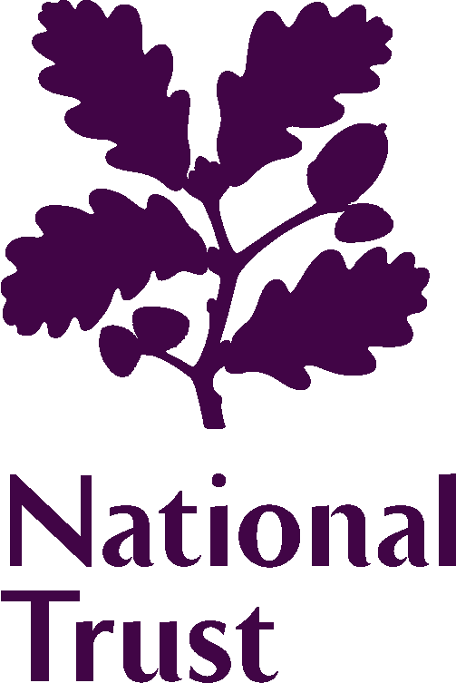 | 2023 Elections to the Council
To help us understand how people heard about this opportunity, so that we can improve our future advertising, please can you tell us how you heard about the election (please choose one option):

Internet and social media channels
[ ] Members E-newsletter  [ ] NT Website  [ ] NT Jobs website | [ ] NT social media posts  [ ] NT Jobs social media advert  [ ] LinkedIn | [ ] Twitter  [ ] Other (please state)  ……………………………
Internal channels
[ ] MyVolunteering  [ ] NT magazine  [ ] Volunteer Manager’s brief | [ ] Property staff or volunteers  [ ] Property poster | [ ] Other (please state)  ……………………………
Other communications
[ ] Acorn  [ ] Personal recommendation | [ ] Governance email | [ ] Other (please state)  ……………………………

Were you a member when you heard about the election?
[ ] Yes | [ ] No

OUR DECLARATION
The personal information collected in the election process will only be used for the purposes of the elections process you have applied for. It will not be used for any other purpose, nor will it be disclosed to any third party.

Only the information that we have indicated as being intended for publication will be made available to our members through the printed election material and on our website.

YOUR CONTACT DETAILS
Name (as you wish it to appear on the ballot paper)
Membership No
Address
Telephone
Email

Continued over…

YOUR AFFIRMATION

- I agree to stand for election to the Council of the National Trust. I have read the information provided to me about the Council. I understand what being a member of the Council involves, and I am willing to devote the time commitment involved. If elected, I will notify the Chair of any potential conflict of interests which I may have in relation to any item being discussed.

- I confirm that the information given in my application is accurate and complete. I know of no reason why I would not be suitable to become a member of the Council of the National Trust, or which would disqualify me from acting as a Trustee of the National Trust if I were to be appointed to that role in the foreseeable future.

- I am over 18.

- I have read the Code of Conduct which applies to all members of the Council and, if elected, I agree to be bound by its provisions.

- I have not been employed as a member of staff in the 23 months prior to the AGM in November 2023.

- I understand that I need to be a member of the National Trust, by no later than 1 May 2023, to be able to go forward for election.

- In the interests of fairness between candidates, I understand that the primary source of publicising my candidacy will be to members via any printed or online election material issued by the National Trust. I confirm that I will not seek methods of publicising my candidature through organised or formal channels. (The use of informal channels such as social media to close friends and family is permissible).

Signed: Dated:

