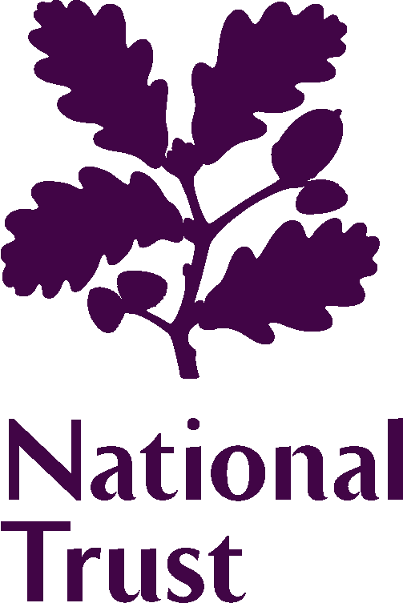 | 2017 Elections to the Council
OUR DECLARATION
The personal information collected in the election process will only be used for the purposes of the elections process you have applied for. It will not be used for any other purpose, nor will it be disclosed to any third party.

Only the information that we have indicated as being intended for publication will be made available to our members through the printed election material and on our website.

YOUR CONTACT DETAILS
Name:
Home address: |  |  | Correspondence address (if different):
Contact telephone number |  | Home:  Mobile:
Email address:
Membership number:
YOUR AFFIRMATION
I confirm I am a member of the National Trust and I agree to stand for election to the Council. I have read the information provided to me about the Council and its role. I understand what being a member of the Council involves, and I am willing to devote the time commitment involved. If elected, I will notify the Chair of any potential conflict of interests which I may have in relation to any item being discussed.
I confirm that the information given in my application is accurate and complete. I have read the information made available to me and I know of no reason why I would not be suitable to become a member of the Council of the National Trust, or which would disqualify me from acting as a Trustee of the National Trust if I were to be appointed to that role in the foreseeable future.
I have read the Code of Conduct which applies to all members of the Council and, if elected, I agree to be bound by its provisions.
I have not been employed as a member of staff in the 23 months prior to the date of the election, 21 October 2017.
In the interests of fairness between candidates, I understand that the primary source of publicising my candidacy will be to members via the National Trust’s printed and online election material. I confirm that I will not seek methods of promoting my candidacy through organised formal/informal channels.

Signed: Dated:

