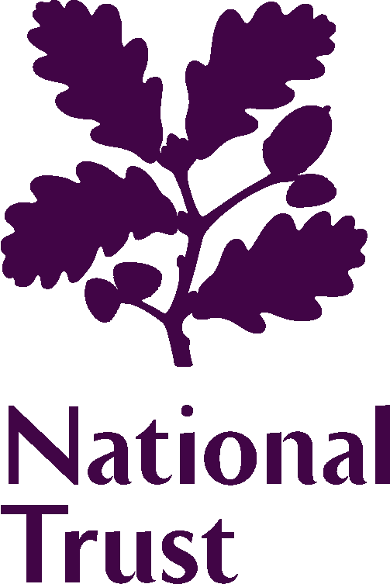 | 2024 Elections to the Council
CANDIDATE INFORMATION TO BE PUBLISHED IN THE ELECTION MATERIAL

The information on this form will be provided to members of the National Trust as part of the election material and will also be published on the National Trust website.

The information you provide will help inform members about who they wish to vote for.

Please complete all seven fields/ boxes, keeping within the word count where appropriate. Please note that the National Trust reserves the right not to publish factually or inflammatory candidate statements.

Information to be published
Your name:
The town/county or area where you live:
Election Statement
This is an opportunity for you to describe why you are interested in joining Council and any supporting information you would like to highlight to members to support your candidacy. You may wish to include any past experiences or interests that would enable you to contribute to the Council’s work. This could include details of how long you have been a National Trust member, and any volunteering experience. Your statement should be no more than 90 words. Statements longer than this may be edited before publication.

Supporting information
Please provide a single sentence response to the following questions. Each response should be no more than 40 words. Responses longer than 40 words may be edited before publication.
1. What is it about the National Trust that inspires you to seek election to its Council?

2. The National Trust seeks to be for everyone, for ever. If successful, what skills and knowledge will you bring to the Council, and to the Trust as a whole to help with this ambition?

3. What do you think should be the National Trust’s focus in its next 10-year strategy (2025-35)?

4. Is there anything else you would like to add to support your election candidacy?

