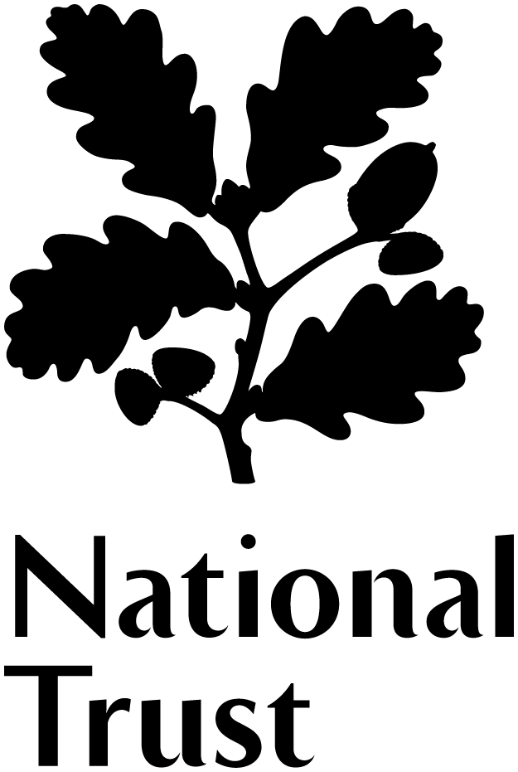

South West Regional Advisory Board
Role description

Our Regional Advisory Board is a group of up to ten volunteers who provide expert support and advice to our Regional Director and his team of staff working across the South West. Board members bring their knowledge of the region, and experience of their own sector, to help the National Trust deliver its ‘Playing our Part’ strategy. Over the next ten years we aim to:

- Look after our land and buildings, taking a long-term view of conservation
- Restore a healthy and beautiful natural environment
- Create experiences of our places that move, teach and inspire
- Help look after the places where people live
- Grow support for what we do
- Develop our resources and skills

Board members come together as a group to help the Regional Director and his team develop their thinking on a strategic priority or theme. Outside of this, Board members act as ambassadors and champions for the National Trust, using their contacts and networks to do so, and may also be invited to provide advice on specific projects or initiatives.

The South West Advisory Board is one of five regional and two country Advisory Boards across the National Trust in England, Wales and Northern Ireland, and the Chairs of the seven Advisory Boards meet twice a year.

This role would suit people who:

- Live in the South West and are knowledgeable about the region, including its organisations, networks and communities
- Are passionate about the historic and natural environment and the National Trust’s core purpose of looking after special places, for ever, for everyone
- Are strong strategic thinkers and able to work as part of a group to look at long-term issues and challenges
- Understand current economic, environmental and/or social trends and the challenges and opportunities they present in the South West
- Are actively engaged in external networks or initiatives that are relevant to the National Trust’s strategy
- Are skilled in working in partnership
- Can bring innovation and latest thinking to help the Trust deliver its strategy
- Have knowledge or experience in one or more of the National Trust’s priority areas
- Share and demonstrate the National Trust’s ‘Values and Behaviours’ (Annex A)
We are working to attract volunteers who reflect our diverse population. To this aim we particularly welcome applications from women, black and minority ethnic individuals and people with disabilities, all of whom are currently under-represented on the Board.

What’s in it for you?

- You will gain or develop your experience of playing an advisory role in a large, complex organisation, which has all the characteristics of a commercial company, a campaigning charity and a public body rolled into one.
- You will be contributing to the work of Europe’s largest conservation charity and helping to shape our response to the conservation challenges of the 21st century.
- You will enjoy debating issues with a diverse group of committed enthusiasts: your fellow Board members, National Trust staff and other volunteers.
- You will be playing a part in protecting some of the country’s finest landscapes and buildings, and helping people to enjoy them.
- You will be thinking about the long-term implications of looking after places of historic interest and natural beauty in the South West.

To help Board perform their role, the National Trust offers:
- Two members of staff who provide support to Board members in their role
- An induction meeting with the Regional Director and an invitation to a central induction day at the National Trust headquarters in Swindon
- Three teleconferences a year with the relevant Assistant Director to discuss issues at a county level
- Regular electronic communications and updates
- Dates for awaydays identified in the autumn of the previous year, to enable you to plan into your agenda and/or working life
- Delegate packs issued three weeks before each Advisory Board awayday
- Reimbursement of reasonable expenses incurred on Trust business

What’s involved

Appointments are made for three years and Board members may be reappointed once (ie for a maximum of six years) if mutually beneficial to do so. Administration is kept light-touch, in keeping with the purely advisory role of the Board.

The Board meets three times a year for strategic awaydays with National Trust staff and volunteers. At least two of these involve an overnight stay on the evening preceding the meeting and they take place at sites across the South West region. Members may also be asked to use their expertise to support projects and other challenges as requested by staff, outside of Board meetings. This is much appreciated by staff and gives members a chance to get closer to the practical activity of the Trust, although it is not expected that every member will be able to commit the time needed. The overall time commitment is an average of one day a month, with meetings held during the working week.

Board members are asked to be open about any relevant responsibilities and positions and declare any conflict of interest. The Regional Director and his team may share confidential or sensitive information with the Board, so members are also required to maintain confidentiality when requested.

